PHET Simulation Activity
Energy Forms and Changes Name: ____________________________
Intro: Thermal Energy
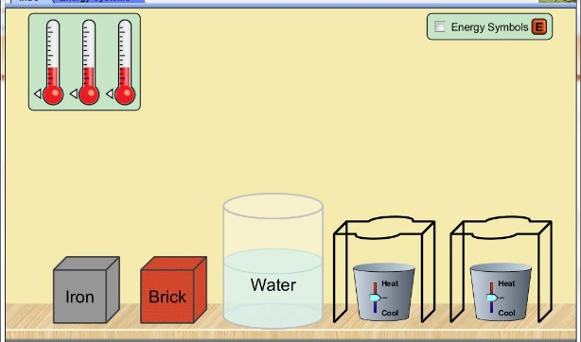

- Go to the Intro tab on the simulation
- Drag and attach thermometers to the iron block, brick, and water—attach on the right hand side.

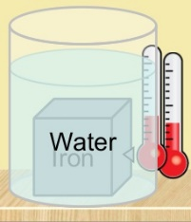
Part 1: Heating

1. Place the iron block on a stand.
2. Drag the temperature slider underneath to heat the block. Heat the
block to its maximum temperature based on the thermometer
reading.
3. Drag and place the iron block into the water.
4. Observe and describe how this affects the temperature of:

a. the iron block
when the heated iron is immersed in water, its temperature drops significantly as it loses heat energy to the water. _____________________________________________________
b. the water.
The water temperature rises as it gains heat energy from the hot iron block. ___________________________________________________________

5. Drag the iron block back to the stand

6. Turn on the energy symbols tab: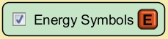 and repeat the process
above.
7. Observe and describe what is happening to the energy symbols as the iron block is
heated, and then placed into the water:
As the iron is being heated, the energy symbols inside it increase and when it is place inside water, the energy symbols in the iron block reduces as those in the water increases.

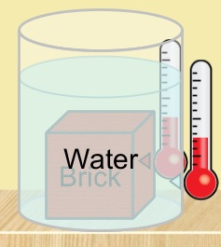
8. Repeat this same process above, but this time, use the brick.

9. When the heated brick is placed into the water, how does this
affect the temperature of:

a. the brick
When the heated brick is placed in water, it loses most of the energy symbols it had gained during heating, hence the resulting drop in temperature. _________________________________________________________
b. the water
The water gain energy symbols lost by the brick, which leads to a rise in temperature.

10. Describe any similarities and differences that you observed for the iron block and
the brick during this process.
Both the iron block and brick gains heat energy when heated and loses the heat when immersed in water.
The brick gains heat energy symbols faster and the temperature rises more swiftly than the iron block.

11. What thermal process is being simulated here? Explain.
Heating as a transfer of thermal energy. Heat energy is being transferred from the iron block and brick to the water with a subsequent drop in temperature.

Part 2: Cooling

1. Repeat this process for both the iron block and brick, but this time cool each to its
maximum low temperature and place into the water. Do this by dragging the tab of
the bin under the stands to create ice.
2. Describe what you observe happening to the objects and the water when combined:
When the objects and the water are combined after cooling them to their maximum low temperature, their temperature rises when immersed in water.

3. Repeat and turn on the energy symbols tab: , then describe what is happening to the energy symbols as the objects are cooled and then placed into the water.
When the iron block is cooled to its maximum low temperature, the energy symbols reduces below the initial number when the block was not heated. When it is immersed in water, some of the energy symbols from the water enters the iron block as the temperature rises.
When the brick is cooled to its maximum low temperature, the energy symbols reduces below the initial number when the block was not heated. When it is immersed in water, some of the energy symbols from the water enters the brick as the temperature rises.

4. How is this process similar to and different from the heating process?
This process is similar to the heating process because it involves change in thermal energy and temperature.
It is different from the heating process because it involves loss of thermal energy while heating involves gaining of thermal energy.

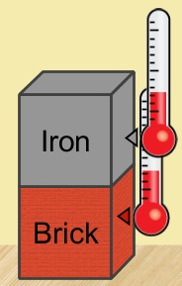
Part 3: Thermal contact properties

1. Heat the iron block to its maximum temperature and place it ON TOP of the brick. Observe and describe what happens to both the iron block and the brick:
When the heated iron block is placed on top of the unheated brick, its temperature reduces as the temperature of the brick rises up to a point when both objects have the same temperature.

2. Heat the brick to its maximum temperature and place it ON TOP of the iron block. Observe and describe any similarities and differences from what you observed in #1.
When the hot brick is placed on top of the unheated iron block, its temperature drops while that of the iron block rises up to a point when they both attain equal temperature.
3. Heat the water to maximum and place it ON TOP of the iron block and the brick. Record the results below:

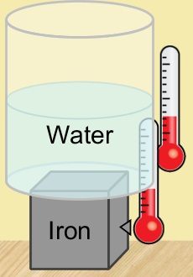
a. water on Iron block:
The temperature of the hot water drops while the temperature of the iron block rises until the two temperatures become equal.

b. water on Brick:
The temperature of the hot water drops while the temperature of the brick rises until the two temperatures become equal.

4. Repeat the processes above, but this time COOL the iron block and the brick. Note any differences in this process below:
When a heated iron block is cooled to its maximum low temperature and then placed on top of the unheated brick, its temperature rises while that of the iron block drops.

When a heated brick is cooled to its maximum low temperature and then placed on top of the unheated iron block, its temperature rises while that of the brick drops.

When heated water is cooled to its maximum low temperature and then placed on top of the unheated brick, its temperature rises while that of the brick drops.

When heated water is cooled to its maximum low temperature and then placed on top of the unheated iron block, its temperature rises while that of the iron block drops.

5. What thermal process is being simulated here? Explain.
Heat exchange between objects. The cold object gains heat energy from the object at room temperature.

6. How is this process different from Parts 1 and 2? Explain.
The process is not different from parts 1 and 2 because they all involve gain and loss of thermal energy from one substance to the other.

7. Investigate: How could you heat/cool and arrange the objects here to show BOTH of the properties mentioned above? Explain: (Hint: Can you stack up all of these objects or put one inside the other one?
The water is placed on the stand in direct contact with the heat source. The two objects, brick and iron block are placed inside the water one top of each other. The temperature of water rises up to its maximum high level. Iron block, the object immersed directly in water gains the heat energy from water and its temperature rises upto the point where it is equal to that of water. Brick, which is on top of the iron block gains thermal energy from equivalent to that in the iron block and its temperature rises up to a point where it is equal to that of iron.

